Student Name
Student ID
Course Code
Date

Table of Contents
Introduction 3
Adaptive Thinking 4
Communication Skills 5
Academic writing 6
Collaboration skills 6
Critical thinking and problem-solving skills 7
Personal Management 8
Inquiry skills 8
Technology Skills 9
Creativity and innovation skill 10
Empathy and perspective 10
Conclusion 10
Reference 11

Introduction
Learning academic skills is a key to becoming more efficient as a student. The skills are highly transferrable, which makes them essential across all careers. The majority of these skills are expected of students when they enter higher education. Communication via academic writing allows you to be able to convey the knowledge you have gained in a certain area of study. As students write academically, they will develop analytical skills, communicate their understanding, act critically, and practice their writing styles. Higher education students who are not proficient in academic writing may find it difficult to demonstrate their knowledge of complex subjects. It is by using the correct phrases and styles in essays and writing assignments that students can summarize what they know (Awan, 2015).
Identifying, understanding, and evaluating information, planning, structuring, editing, and proofreading are all necessary components of academic writing, and together these comprise the basis of university exams. For developing skills in all stages of the process, there are plenty of resources available. Technical writing is closely linked with how ideas should be conveyed in this setting. Writing essays throughout university is much easier if students learn essay style early on. The student learns and gains knowledge using different writing techniques and they improve their writing skills.
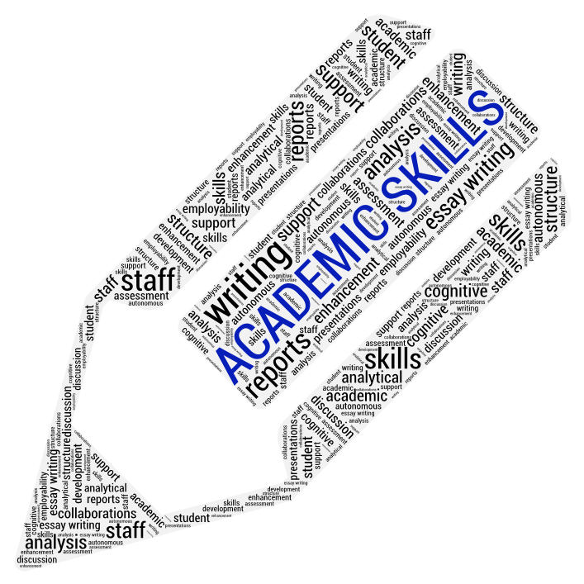
Figure. 1. Academic Skills
Source (Matthews, 2018)
- Thinking adaptively
- Communicative skills
- Writing academically
- Skills for collaboration
- The ability to think critically and solve problems
- Management of individuals
- Skills of Inquiry
- Skills in technology
- Creativity and innovation skill
- Empathy and perspective

Adaptive Thinking
The ability to learn from your workplace environment can be acquired by developing adaptive skills. Generally, when employers are looking for an employee for a position, adaptive skills and abilities that show you can work in an unpredictable workplace are highly valued. It is essential to have resourcefulness and open-mindedness as well as improve communication skills to be adaptive. Adaptable people can overcome obstacles. Student adaptability relates to students' control over their environments, they are less likely to encounter failure-causing variables resulting from anxiety, uncertainty, or procrastination. Adaptability is a valuable tool for career development and achieving more meaning in life when dealing with challenges in their career roles. It lets people smoothly manage the changes that come with their career, and maintain their ability to balance their career roles (Schrager and Smith, 2016).
By adapting to adversity, you'll be better equipped to handle it without letting it get the better of you. Be receptive to change and have a resilient attitude no matter what the workplace throws at you. According to change theorist Ronald A. Heifetz, adaptable change, also known as "learning-based change," when defining and implementing problems," has become increasingly necessary as today's support leaders struggle to overcome rigid policies and procedures in rapidly evolving business environments. Solutions and responses that are novel or adaptive are those that step outside the box of rote or rule-based thinking. Innovative thinking is based on the ability to solve problems, operate quickly, and deal with uncertainty (Reckase, Ju, and Kim, 2019).

Communication Skills
To achieve academic success, a child must have good communication skills. Effective communication is essential for students at any level of education. Communication skills are essential to the development of children so they don't fall behind or withdraw from school because of a lack of communication skills. Children must develop communication skills at every educational level. When children lack effective communication skills at school, they can become overwhelmed emotionally or withdraw from other students. Communication is the key to academic success, starting with clear verbal communication. Class discussions often revolve around students answering class questions. The questions may be simple factual ones or ones that require the student to put his or her thoughts together and make an argument. To assess a student's knowledge, teachers need effective ways of communicating the answers to questions. If a student with a speech impairment cannot communicate on a par with their peers, they may also feel embarrassed. In turn, this can contribute to low grades and poor self-esteem for a student who stutters or mumbles in class (Coffelt, Grauman, and Smith, 2019).
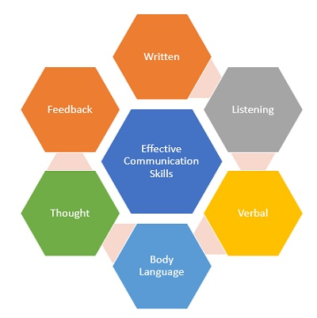
Figure.2. Communication Skills
Source (MBA Skool, 2021)
Using oral language is particularly useful for everyday social interactions and pragmatic communication. The words that are used, the way they are used, as well as non-verbal or non-written communication are discussed here. The language we use to interact with others and navigate our world is important. More and more work is required to be presented in writing as they progress through the educational system. The ability to synthesize complex ideas and concepts, and to write clear explanations, summaries, and conclusions is an essential skill. Clarity of ideas and effective use of language is important, along with an effective tone (Gröppel-Wegener, 2012).

Academic writing
Clear, concise, focused, and structured academic writing draws upon the evidence to back it up. Academic writing aids the reader's comprehension. The writing style and tone of this paper are formal, but not too complex, with straightforward sentences and straightforward vocabulary. The style and tone are formal, but the writing is not long or complex. There are no lengthy sentences or difficult words (Dooley and Walshe, 2019).
As you pursue a degree in any subject, you will become familiar with the grammatical conventions, vocabularies, and kinds of discourse associated with that subject area. The methods of composing academic texts are similar across disciplines, but there are some elements common to them all. An academic essay or research paper in English usually has three main parts: an introduction, a body, and a conclusion. In the introduction, you outline the importance of the topic or issue. A thesis statement concludes the introduction.

Collaboration skills
Studies have shown that collaborative learning not only helps students develop cognitive skills but also boosts their self-esteem and confidence. In addition to improving social and interpersonal skills, group projects maximize the educational experience. Currently one of the strongest core philosophies operating in classrooms is collaborative learning involving students working on projects together and answering questions as a group. Achieving a common goal requires bringing different teams and departments together. Unless everyone is on the same page in terms of skill, I doubt it can happen. Working well together is a skill honed over time, but collaboration is a process (Gardiner, 2020).
For collaborative success, it is also essential to communicate clearly and thoughtfully. Individuals must be able to communicate with one another clearly and thoughtfully. Yet different people express themselves in varying ways. For example, some people are quite comfortable talking in groups while others are not. Maintaining open and transparent communication for your organization requires you to be sensitive to the different styles of communication and adapt accordingly. Self-awareness is essential to effective communication. When it comes to collaborating with others, employees must understand their preferences.

Critical thinking and problem-solving skills
It is crucial to develop students' critical thinking skills so that they can obtain an understanding of the world around them. Students who have critical thinking skills will have an easier time solving problems. Just knowing the facts is insufficient in solving problems. Using knowledge, facts, and data to solve problems effectively is considered problem-solving and critical thinking. It does not mean you have to know the answer right away; rather, you must act quickly, assess the problem, and then present a solution (Abdullaeva et al., 2020).
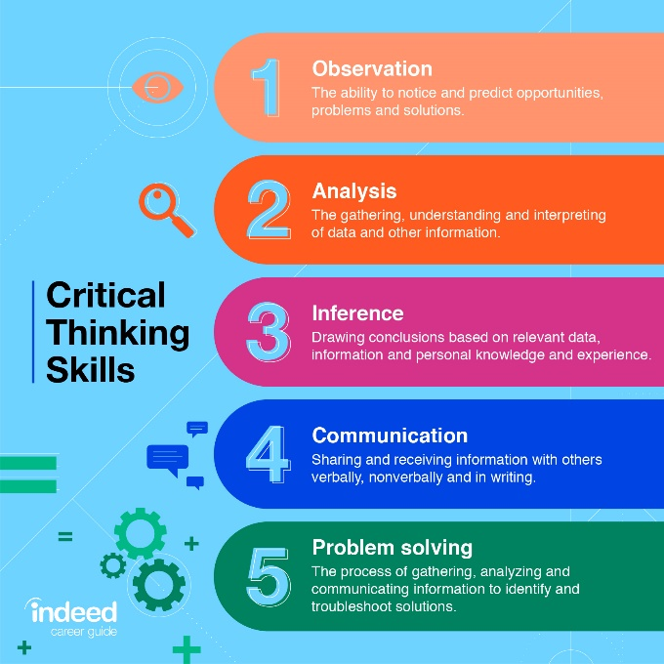
Figure 3. Critical Thinking Skill
Source (Indeed Editorial Team, 2021)
Thinking critically is the key to solving problems effectively for students. Having information and knowledge alone isn't sufficient. The ability to solve problems and make effective decisions is essential to students' success in the workplace (and in their personal lives). School teachers have a great responsibility to develop in students the characteristics that assist them in performing their jobs in the workforce, making decisions, and interacting with others. How does critical thinking benefit us? What are the essential elements of the critical thinking process, and how does critical thinking prevent making poor decisions?

Personal Management
The ability to manage one's time allows students to stay focused in a class by completing assignments, studying for tests, and staying on task. The development of new skills, like professional knowledge, or achieving personal goals are vital to adult development. Self-management involves utilizing specific skills to improve your performance and productivity in the workplace. To reach your goals, you need self-management skills to set and channel your goals. To achieve self-management, everyone needs to develop three skills: (1) developing time management and commitment management skills; (2) becoming motivated and capable of learning new skills independently; and (3) creating and nurturing a network of relationships. A student's ability to monitor, evaluate, and reinforce himself or herself is promoted through self-management strategies. As a result of self-management, one feels in control of their behavior (Deeter-Schmelz, 2012).

Inquiry skills
Asking questions, seeking answers, interpreting the information, and presenting findings constitute the circular process of inquiry skills. Analysis and synthesis skills are developed as a result of this process. Successful teachers encourage their students to be active learners. Promoting inquiry is one method of fostering active learning. Her students enjoy being engaging and learning actively, which is something Francis loves to do. Students should be asked to think creatively, critically, and reflectively when using higher-level thinking skills. In addition to her designing lessons to use these skills throughout the day, she also allows them to apply their skills to many different subject areas. Describe how she does this. Francis designs lessons that require students to use inquiry skills to capitalize on students' natural curiosity. A process of asking questions, researching answers, interpreting information, presenting findings, and reflecting, inquiry skills follow a circular pattern (Yiğit Özüdoğru and Demiralp, 2021).

Technology Skills
The technical skills required to perform specific tasks comprise abilities and knowledge. In terms of applications, they often include mechanical, engineering, or mathematical tasks. A programming language, design program, or mechanical equipment and tool knowledge are examples. As part of their technology learning, students develop digital portfolios or program apps, enabling them to break complicated problems down into smaller, more manageable chunks (Ericksen and Beathea, 2019).
Learning new technological skills now allows students to be in a position to be competitive, as they acquire skills that are directly applicable to their future careers, such as artificial intelligence or blockchain technology, which are causing economic and societal change. Knowing about these technologies is essential to enabling students to achieve success in both formal and informal education.
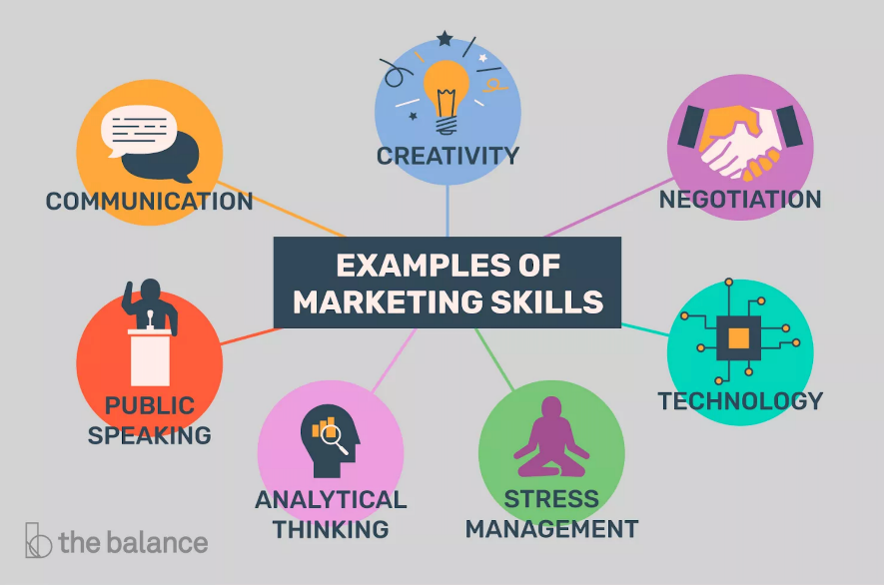
Figure 4. Technical Skills
Source (Katrina Kirsch, 2021)

Creativity and innovation skill
The ability of creativity allows for the development of innovative ideas, which are unique to an individual or a group of people. The ability to use creativity to solve problems sets innovative individuals apart from their peers. Research has shown that students in an environment that supports creativity have a higher sense of success, improved reasoning skills, heightened self-esteem, enhanced resilience, and an enhanced capacity to innovate.
After the invention of the motorcycle, most people discovered it was possible to ride a bike without exerting any additional effort. It just takes a button click and it will start automatically and ride for them. The thought of creating a new traveling motorcycle can be considered creativity, but its creation can be considered innovation (Soltani, 2018).

Empathy and perspective
We can only understand what the other person is thinking by being able to feel empathy for and see things from their perspective. We live in an increasingly complex and globalized society that demands that we understand what other people want. By definition, empathy consists of being able to understand your partner's feelings without any previous experience. Because empathy involves understanding other people's feelings without having any experience, empathy provides students with the opportunity to build relationships beyond school. Communication requires empathy as well. Understanding how others think and feel builds empathy. Empathy involves putting yourself in the place of other people and understanding their thoughts and feelings (Olderbak et al., 2014).

Conclusion
A student's academic skills help him or she become more efficient at learning. Besides being highly transferable, these skills are also important for any career. As students begin their higher education experience, they must have some of these skills. Developing employees' skills and knowledge help them become more competent in their careers, as well as excel at them. This process should be carried out throughout the lifetime of the employee. Keeping skill sets relevant and up to date is accomplished by actively pursuing professional development. Earning a degree is a significant achievement. Your career and general life can be made better through knowledge, skills, and experience. Furthermore, you will be gaining communication and problem-solving skills as well as a sense of self-confidence.

References

Abdullaeva, B., Abduvaliyeva, D., Ruzikulova, N., Yusupova, N. and Ishbaeva, N. (2020). Developing Critical Thinking and Problem-Solving Skills. International Journal of Psychosocial Rehabilitation, 24(Special Issue 1), pp.937–941. https://doi.org/10.37200/ijpr/v24sp1/pr201237
Awan, S.N. (2015). Headway Academic Skills: Listening and Speaking and Headway Academic Skills: Reading and Writing: Introductory Level (Sarah Philpot & Lesley Curnick, 2013). TESL Canada Journal, 32(1), p.70. https://doi.org/10.18806/tesl.v32i1.1202
Coffelt, T.A., Grauman, D. and Smith, F.L.M. (2019). Employers’ Perspectives on Workplace Communication Skills: The Meaning of Communication Skills. Business and Professional Communication Quarterly, 82(4), p.232949061985111. https://doi.org/10.1177/2329490619851119
Deeter-Schmelz, D.R. (2012). Personal Selling and Sales Management Abstracts. Journal of Personal Selling & Sales Management, 32(4), pp.503–513. https://doi.org/10.1080/08853134.2012.957967
Dooley, S. and Walshe, M. (2019). Assessing Cognitive-Communication Skills in Dementia: A scoping review. International Journal of Language & Communication Disorders. https://doi.org/10.1111/1460-6984.12485
Ericksen, K.S. and Beathea, C.J. (2019). TECHNOLOGY IMPACT ON LISTENING SKILLS. Journal of Global Engagement and Transformation, 3(1). https://doi.org/10.52553/30001c
Gardiner, P. (2020). Learning to think together: Creativity, interdisciplinary collaboration and epistemic control. Thinking Skills and Creativity, 38, p.100749. https://doi.org/10.1016/j.tsc.2020.100749
Gröppel-Wegener, A. (2012). Developing Academic Writing Skills in Art and Design through Blogging. Journal of Academic Writing, pp.85–94. https://doi.org/10.18552/joaw.v2i1.41
Olderbak, S., Sassenrath, C., Keller, J. and Wilhelm, O. (2014). An emotion-differentiated perspective on empathy with the emotion-specific empathy questionnaire. Frontiers in Psychology, 5. https://doi.org/10.3389/fpsyg.2014.00653
Reckase, M., Ju, U. and Kim, S. (2019). How Adaptive Is an Adaptive Test: Are All Adaptive Tests Adaptive? Journal of Computerized Adaptive Testing, 7(1), pp.1–14. https://doi.org/10.7333/1902-0701001
Schrager, S. and Smith, M. (2016). Writing skills in academic medicine. MedEdPublish, 5(2). https://doi.org/10.15694/mep.2016.000092
Soltani, Z. (2018). Strengthening The Skill of Creativity and Innovation in Pre-Primary and Primary School Education. International Journal of Applied Research in Management and Economics. https://doi.org/10.33422/ijarme.2018.08.25
Yiğit Özüdoğru, H. and Demiralp, N. (2021). Developing a geographic inquiry process skills scale. Education Inquiry, pp.1–19. https://doi.org/10.1080/20004508.2020.1864883

